House Rent Receipt

Date: 02-June-2020

This is to acknowledge the receipt from Swathi Dogiparthi the sum of rupees 96,000 INR by cash towards house rent of Address LIG-675,bharathi Nagar,BHEL,RC Puram,Lingampally, Hyderabad-502032 for the months from April 2020 to March 2021

Landlard's Address:
Ranga Rao,
First floor,
Single Building,
LIG-675,
Bharathi Nagar,
BHEL,
RC Puram,
Lingampally,
Hyderabad-502032
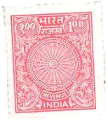

landlard's Signature
Date : 02-06-2020
Place: Hyderabad

